
Bounds Green School Newsletter

13th Feb 2026
A Message from Bounds Green
A Message from Nadine  Dear families,  It has been a wonderful half term at Bounds Green with exciting learning opportunities from our dedicated staff.  We have all been enjoying seeing the children in action at their many performances. The Year Fashion Show is the absolute highlight of the whole year! It was wonderful to see the children's creative T-shirts designs and watch their confidence as they paraded on our "catwalk". Thank you to all Year 1 staff for giving our children this unique experience. We have also seen Reception children singing for families. Their enjoyment and musicality were beautiful to see. Please see the end of this newsletter for details of future performances.  I wish you a happy and restful half term break and we are all looking forward to seeing you again on Monday 23rd February for more exciting learning.  Best wishes,  Nadine  Haringey Free Cycle Training - February Half Term  Haringey Council and Cycling Instructor Ltd are running FREE cycle training for children during February half term. The training will be held at Lordship Recreation Ground.  Dates:  LTR (Beginner), 16th & 17th Feb 9.30am -11.30am  LTR (Beginner), 16th & 17th Feb 12.00pm - 14.00pm  LTR (Beginner), 18th & 19th Feb 9.30am - 11.30am  Level 1, 18th & 19th Feb 12.00pm - 14.00pm  https://haringey.gov.uk/events/free-cycle-training-february-half-term  The booking link is -  https://fs19.formsite.com/cycling/pvjpesdvm4/index  A Gentle Reminder for Pick-Up Time    Please remember that once you have collected your child or children at home time, we kindly ask that you exit the school grounds promptly. We have a number of after-school activities and our After School Club running each day, and these groups use the playgrounds and outdoor spaces. Leaving the site promptly helps us keep these areas safe and ensures all activities can run smoothly. Thank you for your cooperation.    Sustainable Haringey News- February 2026  Please click on link to see more news and events:  Monthly Mailout | www.SustainableHaringey.org.uk  Inclusion Trip to Highgate School  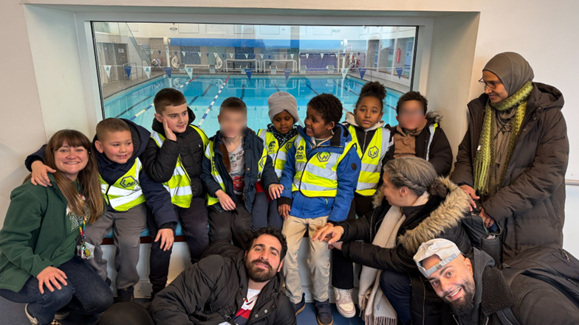  Our Inclusion trip to Highgate School for a gymnastics session was a fantastic experience. The children had the opportunity to practise a range of movements, including balancing, rolling and jumping, while building confidence and coordination. Everyone listened carefully to instructions, showed great enthusiasm and supported one another throughout the session. It was wonderful to see everyone challenging themselves and enjoying being active in a new environment. |  | Nut-Free School    Please remember that we are a nut-free school, this includes After School Club. Please don’t pack an After School Club snack for your child that includes nuts, such as; peanut butter sandwiches, granola bars (as many also contain nuts), etc.  No sesame at School  To help keep all our Pupils/staff safe, we ask families not to send any food containing sesame or sesame products (such as hummus, tahini, or sesame seeds) in lunches or snacks. Thank you for supporting a safe and healthy environment for everyone!  School Payments  As an on-going reminder we’d like to make sure parents and carers keep up to date with their school payments. You can make payment via School Gateway using your mobile and email address. If you are having any troubles with creating an account or logging in, please make sure that the office has the most up-to-date information for you.  Reporting Absences and Late Collections  If you need to report your child absent for any reason (sickness, appointment, etc) then please make sure you do this through the voicemail service on the phone, or through a text on School Gateway. Please don’t email the admin email address as this is not continually monitored, especially during busy periods so may not be seen until later in the day.  For any late collections or if someone different is collecting, please also call directly to the office with as much notice as possible so that it can be passed onto the teacher  Children’s absence/signing Children in/out:  Please remember that if your child has had or needs to have any time off, or if there are any planned absences (such as holidays), it is important to communicate this directly with the school office. Kindly do not inform the teacher about these absences. The office needs to have accurate records for our attendance system, and will inform your child’s teacher for you.  Additionally, if your child arrives late due to an appointment or other reasons, please ensure that they are signed in at the office. If you need to collect your child early (e.g., for an appointment or because they have been unwell), please sign them out at the office as well.  These procedures are in place to ensure we have accurate information for safety purposes, especially in the event of an emergency or fire alarm.    Attendance and Punctuality  For more information about Children’s attendance and punctuality at school, please see this information on our School’s website, please see link below:  Bounds Green School Attendance and Punctuality  

School News
Front Gate Reminder    This is a polite reminder to request that parents/carers don’t prop any of the gates open, mainly the front gate to the school, when entering please do not allow other adults to follow into school, ask them to buzz and give their name and reason for entering.  The gate needs to remain closed at all times for security reasons, especially during the school day when the children are in. If the gate does need to propped open, it is only for school staff to do.  Thank you for keeping our school site safe. |  | Useful links to our website:  Term-Dates-2025-2026.pdf  Bounds Green Primary School | School Menu  Bounds Green Primary School | Contact Us  Bounds Green Primary School | External Clubs
Music Performance Dates

Performance | Date | Year group
WCIT – Violin Performance | Wed 11th March  2:45pm – Lower Hall | RS and Yr5 Continuers
WCIT – Trumpet/Clarinet Performance | Thursday 19th March  9:15am – Lower Hall | LS and Yr5 Continuers
WCIT – Guitar Performance | Monday 23rd March  2:45pm – Lower Hall | ES and Yr5 Continuers
Dance Performance | Friday 27th March  9:15am - Lunch hall | Reception – CW Class only
Dance performance | Tuesday 21st April  9.15am - Lower Hall | Year 3

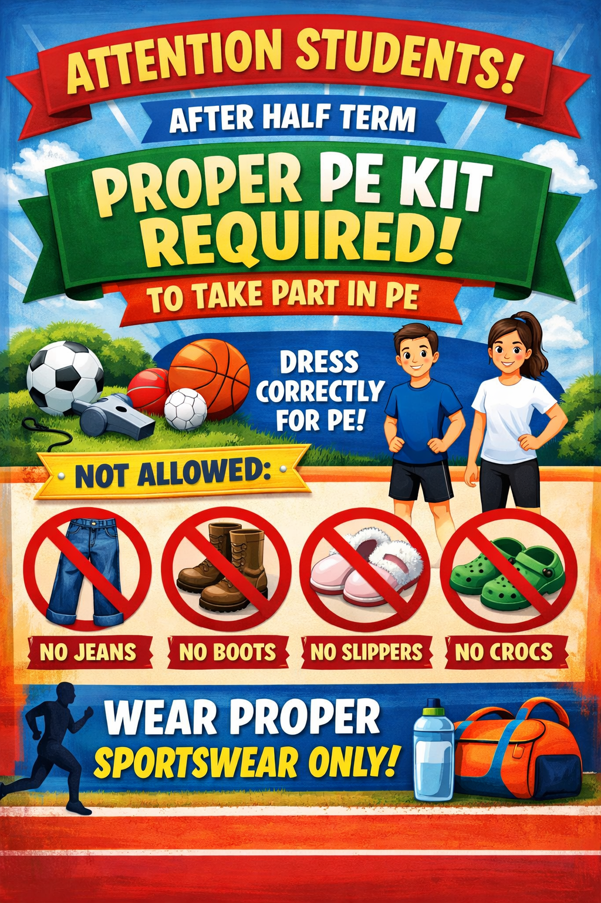

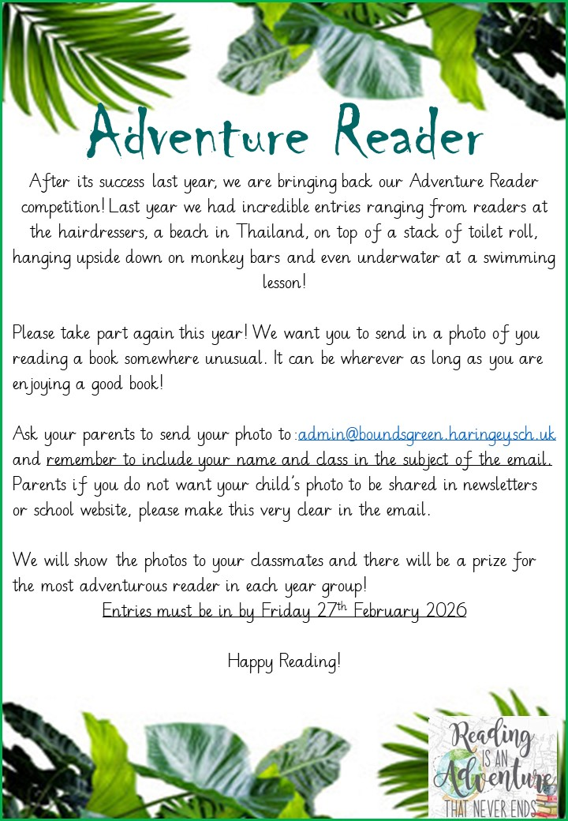
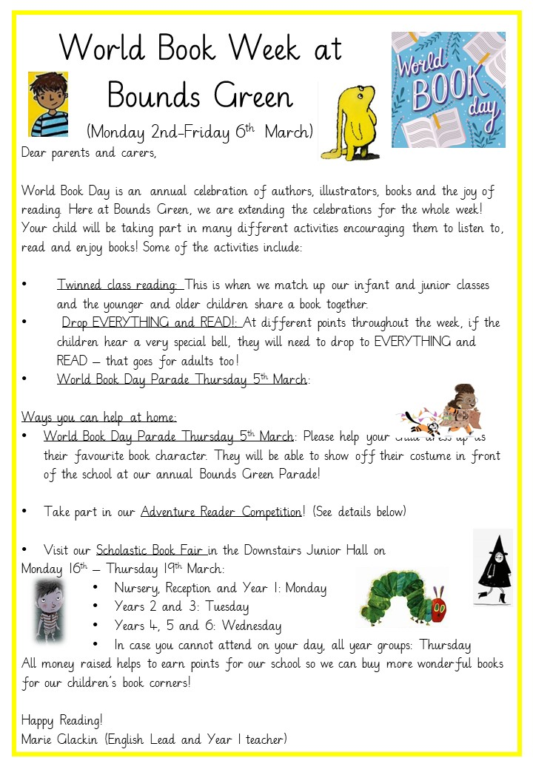


Important Dates
Dates for your Diary
Below are important dates of which you should be aware. Wherever there is a new addition, it will be printed in bold and highlighted in yellow so that it stands out. In the case of Educational Visits, we aim to give as much notice as possible, however, please be mindful that occasionally last minute, educationally enriching opportunities arise which are considered too good an opportunity to pass up. Please look at this section of the newsletter every week as there are sometimes unavoidable changes to dates that you will need to take note of.

Important Note on Dates:
We aim to provide parents with advance notice of important dates; however, due to various factors, sometimes these dates may need to be adjusted. For many of our performances, we work with external teachers who have other commitments, and we also need to balance performances across the school. We appreciate your understanding and flexibility if any changes occur.

February 2026  - 23.02.26 - Return to school  - 24.03.26-RP trip to St Paul’s Cathedral  - 27.03.26-HP &GP trip to St Paul’s Cathedral | June 2026
March 2026  - 09.03.26- Lanzarote trip (Selected Y5 Children)  - 11.03.26 – RS &Y5 Violin Concert - 2:45pm, Lower hall  - 16.03.26- MH Trip to V&A Museum  - 18.03.26-CF Trip to V&A Museum  - 19.03.26 – LS &Y5 Trumpet/Clarinet Concert - 9:15am, Lower hall  - 19.03.26- Y5-London Sinfonietta trip  - 20.03.26-SC Trip to V&A Museum  - 23.03.26- Rec trip to Pickled Pepper Book Shop  - 23.03.26 – ES & Y5 Guitar Concert-9:15am, Lower hall  - 27.03.26 – CW Dance Performance-9:15am, Lunch Hall  27.03.26 - Last day (Easter holidays) | July 2026  - 03.07.26 – INSET Day – school closed  - 17.07.26 – Last day of School  - 20.07.26 – INSET Day – school closed
April 2026
- 13.04.26 - Return to school
- 21.04.26-15.40-19.20 Parents’ Evening
- 21.04.26-Y3 Dance performance- Lower hall 9.15am
- 23.04.26-15.40-17.20 Parents’ Evening
May 2026
- 04.05.26 – Bank Holiday – School Closed
- 07.05.26 - School Closed (Polling Station for Borough elections)
Week Beginning 26/01/26
Attendance Winners  for Yr1-2  Percentage of attendance | Regents Park & Hyde Park | 95%
Attendance Winners  for Yr3-4  Percentage of attendance | Putney Bridge | 99%
Attendance Winners  for Yr5-6  Percentage of attendance | Island Gardens | 96.7%
Week Beginning 02/02/26
Attendance Winners  for Yr1-2  Percentage of attendance | Regents Park | 98.2%
Attendance Winners  for Yr3-4  Percentage of attendance | Putney Bridge | 99%
Attendance Winners  for Yr5-6  Percentage of attendance | Covent Garden | 97.3%






