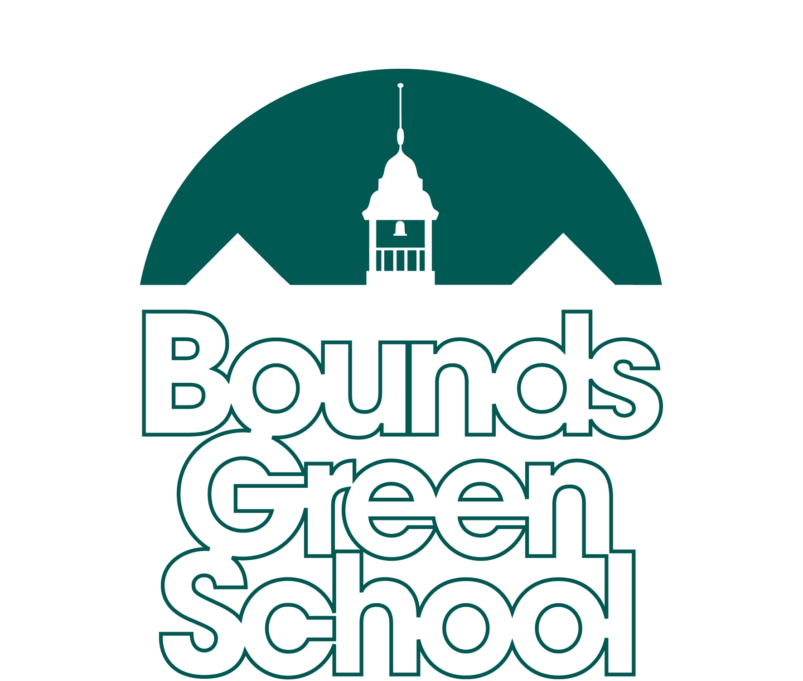
Child’s Name:__________________________________

Head Teacher – Will Wawn
Bounds Green Road
London
N11 2QG
Tel: (020) 8888-8824
Fax: (020) 8365-7986
www.boundsgreenschool.co.uk

Nursery Application Form - Autumn 2023

Please read this form carefully and complete as accurately as possible.
This form needs to be returned by 5pm Friday 17th March 2023.

Failure to do this may harm your chances of getting your preferred type of nursery place.
All prices quoted in this application form are for the current academic year and may be subject to a small increase.
Please bear this in mind when planning for your child’s place.

Are you entitled to a FREE OF CHARGE full time (30 hours per week) nursery place? (9am-3pm, Mon-Fri)

You are entitled if:
- Both parents (or if a Lone Parent family, the parent) are paid the equivalent of 16 hours per week at a minimum pay scale of the National Living Wage (£5,563 per year). This includes self-employed people and people on a zero hours contract.
- Both parents (or if a Lone Parent family, the parent) earn under £100,000 per year.

If this criteria DOES NOT apply to you, you may still be entitled if:
- Both parents are employed but one of them is temporarily away from work on either:
- Parental Leave
- Maternity Leave
- Paternity Leave
- Adoption Leave
- Statutory Sick Pay
- One parent is employed and the other has substantial caring responsibilities for which they receive benefits.
- One parent is employed and the other is disabled or incapacitated and receive benefits for this.

All 30 hour offers are conditional on receiving a valid code from the Government. – which is renewed every 3 months

Not entitled? Don’t worry!
If you are not entitled to the free 30 hour nursery education childcare place, you are still entitled to 15 hours.
If you need more hours, we are able to offer a limited number of top up places priced at only £16 per half day.

What do you think you are entitled to? (Please tick)

I think I am entitled to 30 hours  (Applicable if both parents are working, or if you are a single parent then you are working)  I already have my child’s 30hr code:  _______________________________________  (This needs to be renewed every 3 months to stay valid) | I am interested in a 15hr place  I think I’m eligible for 30hrs, but if it can’t be offered for any reason I would still be interested in a 15hr place
Child’s Details:
Child’s first name(s): | Child’s surname:
Child’s date of birth: | Child’s gender (please delete as appropriate):  Male / Female
Child’s Address (including full postcode):

Parent’s Details
Parent 1 | Parent 2
Full name: | Full name:
Gender: Male / Female / Prefer not to say | Gender: Male / Female / Prefer not to say
Relationship to Child: | Relationship to Child:
National Insurance No:  (only if applying for a 30 hour place) | National Insurance No:  (only if applying for a 30 hour place)
Occupation:  (only if applying for a 30 hour place) | Occupation:  (only if applying for a 30 hour place)
Address (if different to childs): | Address (if different to childs):
Telephone (mobile) : | Telephone (mobile) :
Telephone (home) : | Telephone (home) :
Email: | Email:

Does your child have any brothers or sisters that currently attend Bounds Green School and will still be in attendance in September 2023? If yes, please provide details below.
Name: | Class:
Name: | Class:

Please note that if you are applying for a 30 hour place it might be worth also stating which 15 hour place you would consider (on the next page), so if we aren’t able to offer you your first choice of 30 hours we can offer a second choice of 15 hours.

Please also remember that if you apply for a 30hr place you will need to renew your valid code every 3 months otherwise it expires.

If you were to have a 15 hour place, which type of Nursery place would you like? (Please tick or circle your first AND second AND third )

1st Choice | MORNING  (9am-12pm, Mon-Fri) | MONDAY - WEDNESDAY  (9am-3pm, Mon-Tues and 9am-12pm, Weds) | WEDNESDAY - FRIDAY  (12.30-3.30pm, Weds and  9am-3pm, Thurs-Fri)
2nd Choice | MORNING  (9am-12pm, Mon-Fri) | MONDAY - WEDNESDAY  (9am-3pm, Mon-Tues and 9am-12pm, Weds) | WEDNESDAY - FRIDAY  (12.30-3.30pm, Weds and  9am-3pm, Thurs-Fri)
3rd Choice | MORNING  (9am-12pm, Mon-Fri) | MONDAY - WEDNESDAY  (9am-3pm, Mon-Tues and 9am-12pm, Weds) | WEDNESDAY - FRIDAY  (12.30-3.30pm, Weds and  9am-3pm, Thurs-Fri)

Breakfast Club, After School Club and Nursery Extended Day

- You will be able to apply formally for these sessions once your child’s nursery place is finalised.
- If you are interested in any of these options please indicate below.
- Please bear in mind whilst we will do our utmost to accommodate your needs there is a maximum capacity for both the Breakfast Club, the After School Club and the Nursery Extended Day, therefore we cannot guarantee to offer you what you request
Breakfast Club
Breakfast club currently costs £3.00 per session (subject to change) and runs from 8am-9am. Children are provided with breakfast and activites and then taken to their classes by members of the Breakfast Club Team.
I am interested in my child using the Breakfast Club (subject to availability)

After School Club
For Nursery children, After School Club runs from 3pm-6.15pm and costs £16. For those children in Nursery who have a 15 hour, Wednesday-Friday place, it will be slightly cheaper on a Wednesday because Nursery will finish at 3.30pm, rather than 3pm. For the Wednesday only, the cost is £14.00.
I am interested in my child using the After School Club (subject to availability)

Nursery Extended Day
For those children taking up a 15 hour place, the option to buy more hours is available to you. This means, if your child is in nursery for the morning option, you are able to convert the half day in to a full day (9am-3pm). The cost for this option is £16 per half day (subject to change).
I am interested in purchasing additional school hours in Nursery (subject to availability)

Does your child attend a nursery or pre-school setting at the moment? (If yes, please provide details below)
Name of setting: | Telephone number: | Address:

Is there any other information you would like to share with us about your child or your preference? (Optional)

Please sign below to confirm that the information you have provided is accurate and return to Bounds Green School (for the attention of Katherine Still) either to the main office in the school, or via email by 5pm on Friday 17th March 2023. Please note that late applications will be treated as such and may harm your chances of getting one of your preferred options.

We break up for the Easter holidays from Friday 31th March and returning on Monday 17th April. We aim to contact you by the end of April with your child’s formal offer of a nursery place. Please look out for an email with your offer. Please do not hesitate to call the school office if you have any questions or queries, the main email address is: admin@boundsgreen.haringey.sch.uk

Thank you for your interest in Bounds Green School.

Print Name ________________________ Sign Name_________________________ Date_____________

