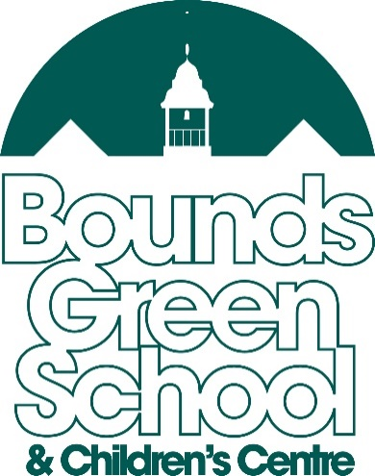

Head Teacher – Will Wawn
Bounds Green Road
London
N11 2QG
Tel: (020) 8888-8824
Fax: (020) 8365-7986
www.boundsgreenschool.co.uk
SITE SUPPORT ASSISTANT
To start September 2021
NJC SCALE 4
36 hours per week, all year round

We are seeking to appoint an energetic and self-motivated person to work supporting our Site Manager in the management and maintenance of the schools’ premises. Duties within the position will include carrying out minor repairs and maintenance, gardening, assisting with site security and undertaking aspects of cleaning of the school. The successful candidate will require excellent maintenance skills in order to be able to assist in the smooth running of a busy school, by ensuring the cleanliness and the Health and Safety of the premises is kept to the highest standard.

The successful applicant should have excellent attendance and punctuality, and will be required to work a 36 hour week with varying start and finish times between the core hours of 6:00am to 6:30pm, Monday to Friday.

What we can offer you
- A dedicated and supportive Leadership Team
- A supportive Line Manager and Site Manager
- A team of cleaners, who are friendly, and committed to ensuring the highest standards are achieved
- Professional development opportunities
- There may be regular overtime opportunities to enhance the basic salary. We are hoping to be able to have regular evening and weekend lets in the future, which will need to be covered on a rota basis between the Site Team.

To request an application form, please contact the school office, in person, by telephone or by email (recruitment@boundsgreen.haringey.sch.uk). You can also download the application pack from our school website – www.boundsgreenschool.co.uk

We welcome, and would strongly encourage, visits from prospective candidates – please contact the school to make an appointment to meet Alan Wright, our Site Manager.

The school is committed to safeguarding and promoting the welfare of children and young people and expects all staff and volunteers to share this commitment. The successful applicant will be subject to an enhanced DBS check.

Closing Date: 09/07/2021
Interviews: w/c 19/07/2021

